Write a C program to draw a triangle using graphics functions.
#include <graphics.h>
// Triangle
int main() {
int gd = DETECT, gm;
initgraph(&gd, &gm, (char*)"C:\\Dev-Cpp\\MinGW32\\lib");

line(100, 200, 200, 200); // base
line(100, 200, 150, 100); // left side
line(200, 200, 150, 100); // right side

getch();
closegraph();
return 0;
}
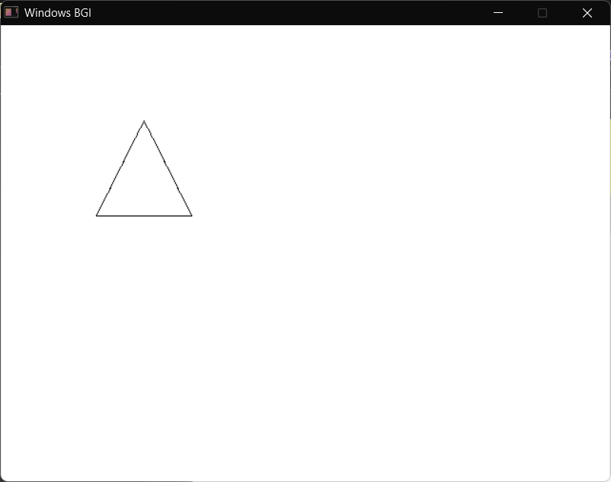

Write a C program to draw a left-hand side right-angled triangle using graphics functions.
#include <graphics.h>
#include <conio.h>

int main() {
int gd = DETECT;
int gm;
initgraph(&gd, &gm, (char*)"C:\\Dev-Cpp\\MinGW32\\lib");

int tri[] = {
200, 200,
200, 350,
300, 350,
200, 200
};

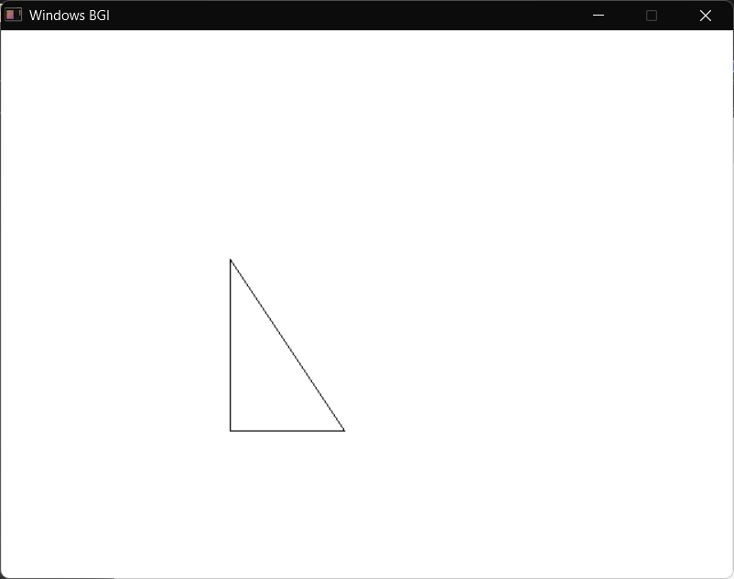
drawpoly(4, tri);

getch();
closegraph();
return 0;
}

Write a C program to draw a square using graphics functions.
#include <graphics.h>
// Rectangle / Square
int main() {
int gd = DETECT, gm;
initgraph(&gd, &gm, (char*)"C:\\Dev-Cpp\\MinGW32\\lib");

rectangle(100, 100, 200, 200);

getch();
closegraph();
return 0;
}
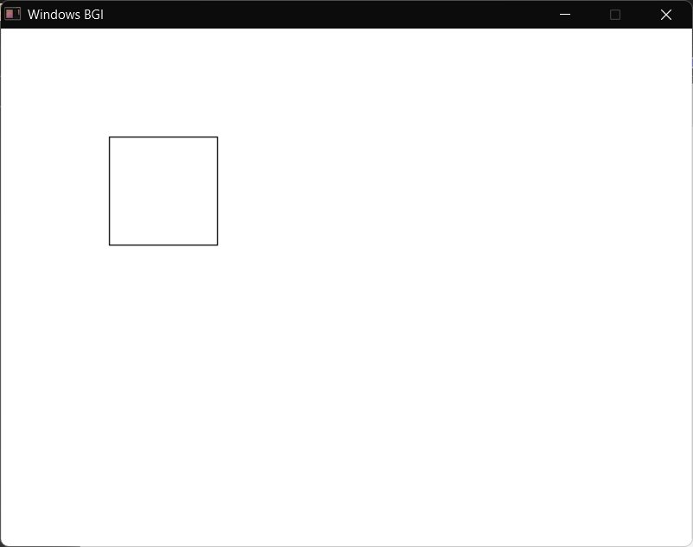

Write a C program to draw a rectangle using graphics functions.
#include <graphics.h>
#include <conio.h>

int main() {
int gd = DETECT;
int gm;
initgraph(&gd, &gm, (char*)"C:\\Dev-Cpp\\MinGW32\\lib");

// Draw rectangle
rectangle(200, 150, 450, 350);

getch();
closegraph();
return 0;
}
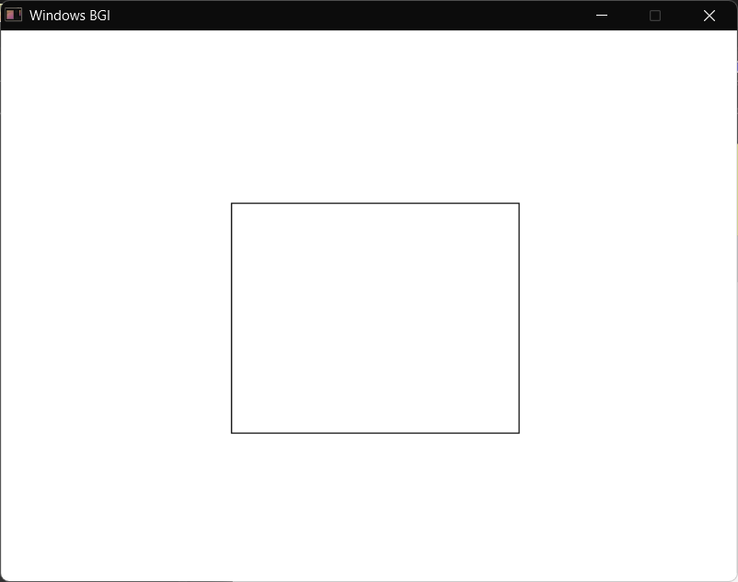
Write a C program to draw a star polygon using graphics functions.
#include <graphics.h>
int main() {
int gd = DETECT, gm;
initgraph(&gd, &gm, (char*)"C:\\Dev-Cpp\\MinGW32\\lib");

int points[] = {
200,100,
240,200,
150,140,
250,140,
160,200,
200,100
};

drawpoly(6, points);

getch();
closegraph();
return 0;
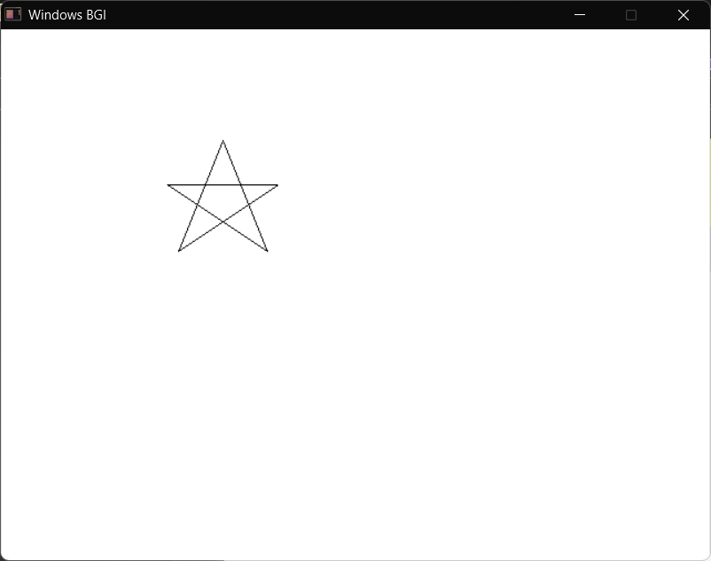
}

Write a C program to draw a pentagon (house-shaped figure) using graphics functions.
#include <graphics.h>
int main() {
int gd = DETECT, gm;

initgraph(&gd, &gm, (char*)"C:\\Dev-Cpp\\MinGW32\\lib");

int points[] = {
200,150,
300,150,
300,250,
250,300,
200,250,
200,150
};

drawpoly(6, points);

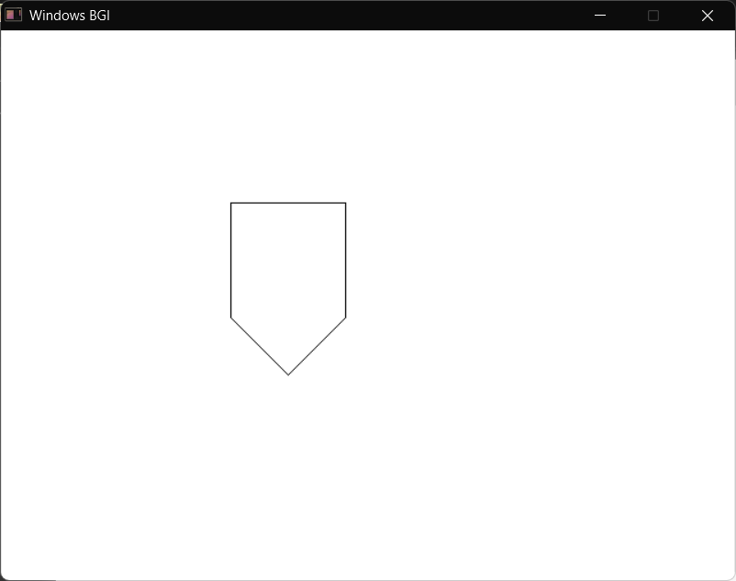
getch();
closegraph();
return 0;
}

Write a C program to draw an octagon using graphics functions.
#include <graphics.h>
int main() {
int gd = DETECT, gm;
initgraph(&gd, &gm, (char*)"C:\\Dev-Cpp\\MinGW32\\lib");

int points[] = {
200,100,
300,100,
350,150,
350,250,
300,300,
200,300,
150,250,
150,150,
200,100
};

drawpoly(9, points);

getch();
closegraph();
return 0;
}

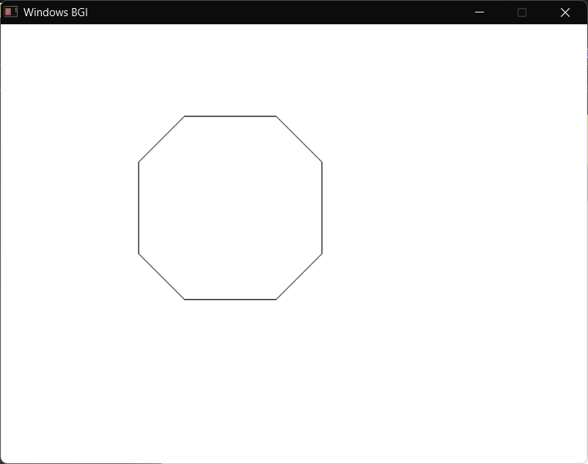

Write a C program to draw a regular hexagon using graphics functions.
#include <graphics.h>
int main() {
int gd = DETECT, gm;
initgraph(&gd, &gm, (char*)"C:\\Dev-Cpp\\MinGW32\\lib");

int points[] = {
250,100,
350,150,
350,250,
250,300,
150,250,
150,150,
250,100
};

drawpoly(7, points);

getch();
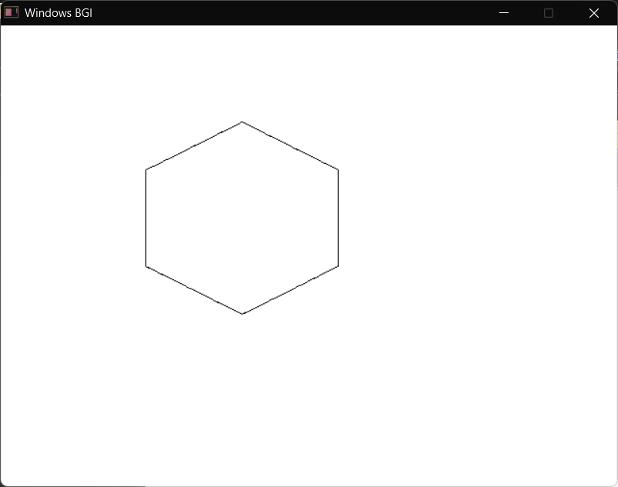
closegraph();
return 0;
}

Write a C program to draw a kite with a triangle tail using graphics functions.
#include <graphics.h>
// Kite with Triangle Tail
int main() {
int gd = DETECT, gm;
initgraph(&gd, &gm, (char*)"C:\\Dev-Cpp\\MinGW32\\lib");

int kite[] = {
250,100,
320,200,
250,300,
180,200,
250,100
};
drawpoly(5, kite);
line(250,100, 250,300);
line(180,200, 320,200);
int tri[] = {
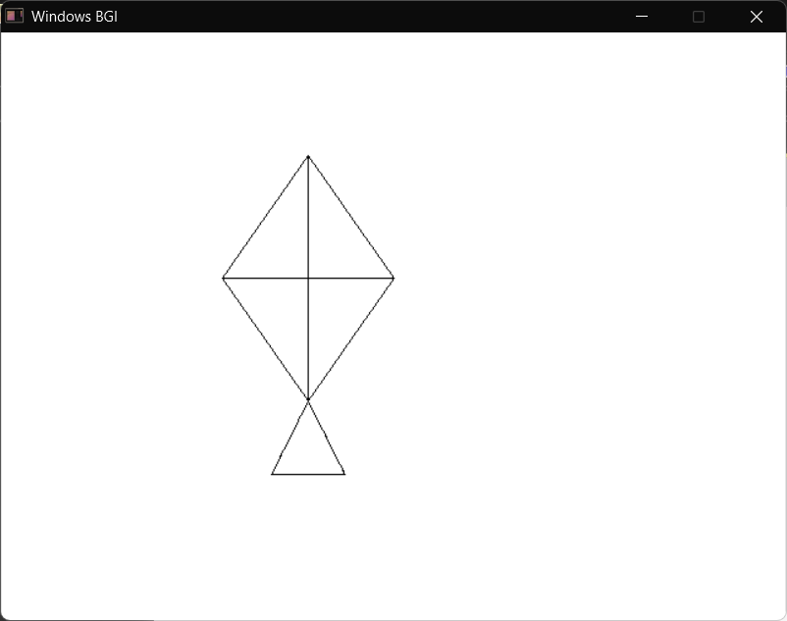
250,300,
280,360,
220,360,
250,300
};
drawpoly(4, tri);
getch();
closegraph();
return 0;
}
Write a C program to draw different types of triangles (Scalene, Isosceles, Equilateral, Acute, Obtuse, and Right-angled) using graphics functions.
#include <graphics.h>
int main() {
int gd = DETECT, gm;
initgraph(&gd, &gm, (char*)"C:\\Dev-Cpp\\MinGW32\\lib");

// Scalene Triangle
line(50,200, 120,100);
line(120,100, 180,220);
line(180,220, 50,200);

// Isosceles Triangle
line(250,200, 300,100);
line(300,100, 350,200);
line(350,200, 250,200);

// Equilateral Triangle
line(450,200, 500,100);
line(500,100, 550,200);
line(550,200, 450,200);

// Acute Triangle
line(50,350, 120,270);
line(120,270, 180,350);
line(180,350, 50,350);

// Obtuse Triangle
line(250,350, 350,300);
line(350,300, 400,350);
line(400,350, 250,350);

// Right Triangle
line(500,350, 500,270);
line(500,350, 580,350);
line(500,270, 580,350);

getch();
closegraph();
return 0;
}

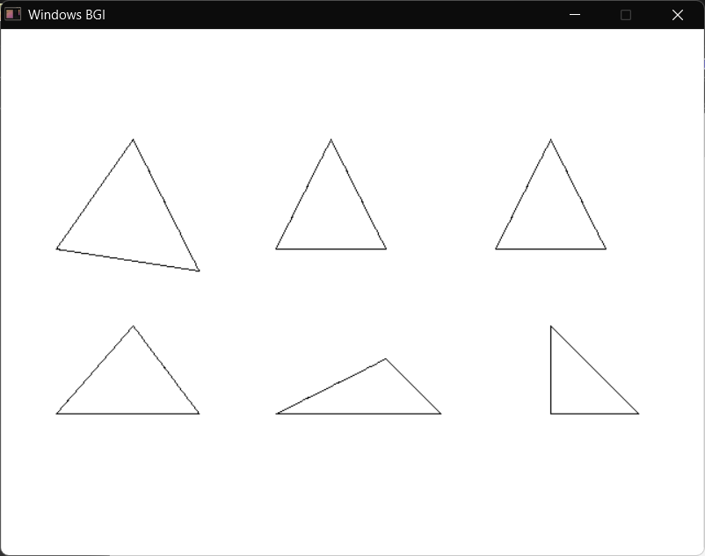

Write a C program to draw a circle using graphics functions.
#include <graphics.h>
#include <conio.h>

int main() {
int gd = DETECT;
int gm;
initgraph(&gd, &gm, (char*)"C:\\Dev-Cpp\\MinGW32\\lib");

circle(320, 240, 100);

getch();
closegraph();
return 0;
}
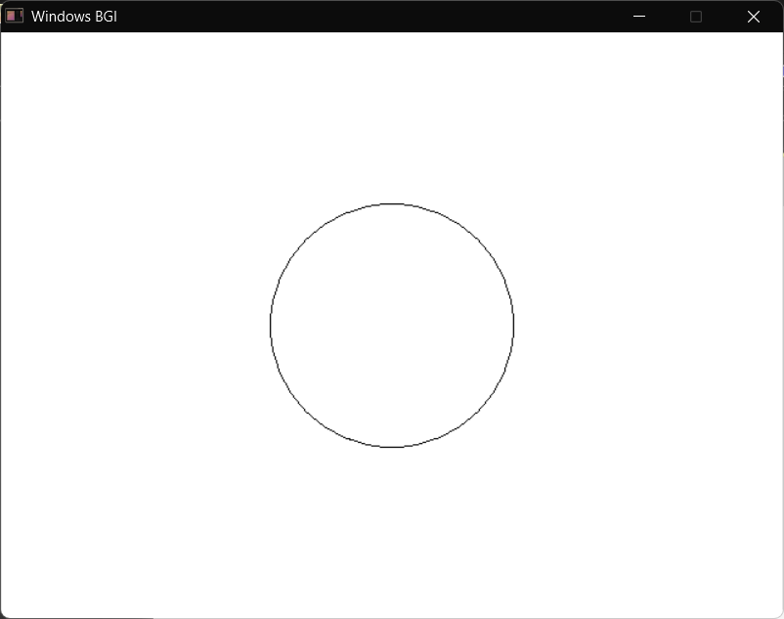

Write a C program to draw a star shape using graphics functions.
#include <graphics.h>

int main() {
int gd = DETECT, gm;
initgraph(&gd, &gm, (char*)"C:\\Dev-Cpp\\MinGW32\\lib");

int star[] = {
300,100,
340,200,
450,200,
360,260,
400,360,
300,300,
200,360,
240,260,
150,200,
260,200,
300,100
};

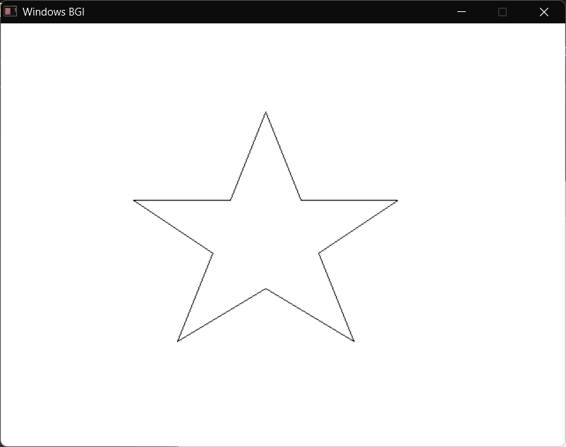
drawpoly(11, star);

getch();
closegraph();
return 0;
}

Write a C program to draw a human face using graphics functions.
#include <graphics.h>

int main() {
int gd = DETECT, gm;
initgraph(&gd, &gm, (char*)"C:\\Dev-Cpp\\MinGW32\\lib");

// face
circle(300,200,100);

// eyes
circle(260,170,10);
circle(340,170,10);

// nose
line(300,180, 290,220);
line(290,220, 310,220);
line(310,220, 300,180);

// mouth
arc(300,240, 200,340, 40);

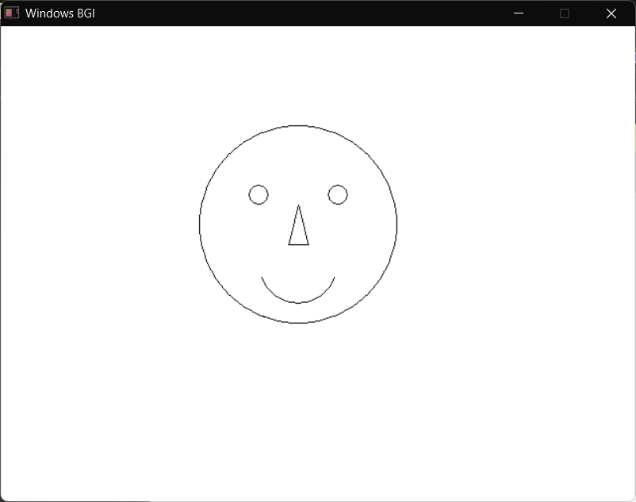
getch();
closegraph();
return 0;
}

Write a C program to draw different types of lines such as straight, dotted, dashed, wave (using arc), and zig-zag using graphics functions.
#include <graphics.h>

int main() {
int gd = DETECT, gm;
initgraph(&gd, &gm, (char*)"C:\\Dev-Cpp\\MinGW32\\lib");
setlinestyle(SOLID_LINE,0,2);
line(100,100,500,100);
setlinestyle(DOTTED_LINE,0,2);
line(100,150,500,150);

setlinestyle(DASHED_LINE,0,2);
line(100,200,500,200);

setlinestyle(SOLID_LINE,0,2);
arc(150,260,0,180,30);
arc(210,260,180,360,30);
arc(270,260,0,180,30);
arc(330,260,180,360,30);

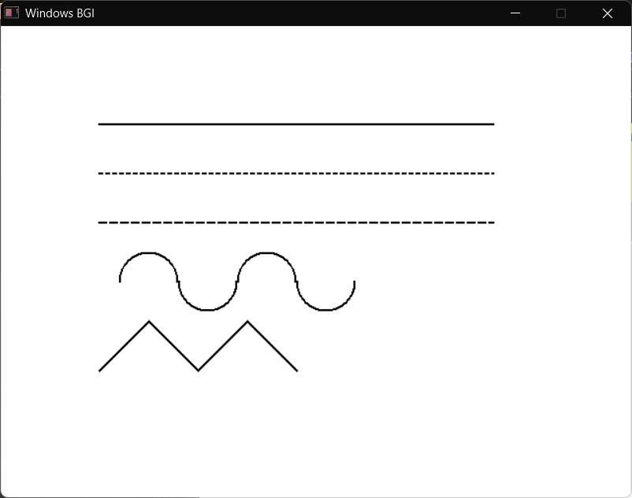
line(100,350,150,300);
line(150,300,200,350);
line(200,350,250,300);
line(250,300,300,350);
getch();
closegraph();
return 0;
}
Write a C program to draw a pie chart with different colors using graphics functions.
#include <graphics.h>

int main() {
int gd = DETECT, gm;
initgraph(&gd, &gm, (char*)"C:\\Dev-Cpp\\MinGW32\\lib");

// Slice 1
setfillstyle(SOLID_FILL, RED);
pieslice(300,200, 0, 90, 100);

// Slice 2
setfillstyle(SOLID_FILL, GREEN);
pieslice(300,200, 90, 180, 100);

// Slice 3
setfillstyle(SOLID_FILL, BLUE);
pieslice(300,200, 180, 270, 100);

// Slice 4
setfillstyle(SOLID_FILL, YELLOW);
pieslice(300,200, 270, 360, 100);

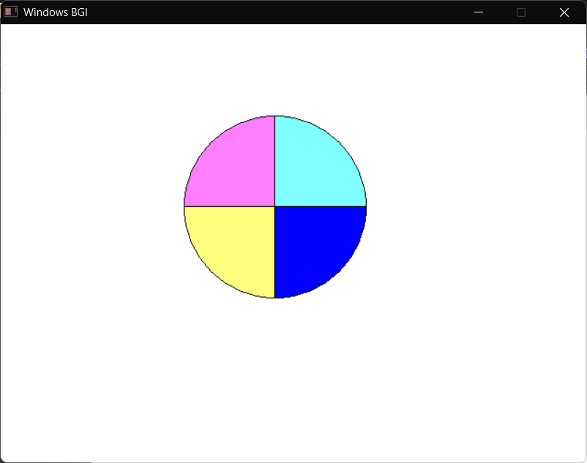
getch();
closegraph();
return 0;
}

Write a C program to draw concentric circles using graphics functions.
#include <graphics.h>

int main() {
int gd = DETECT, gm;
initgraph(&gd, &gm, (char*)"C:\\Dev-Cpp\\MinGW32\\lib");

circle(300,200,20);
circle(300,200,40);
circle(300,200,60);
circle(300,200,80);
circle(300,200,100);

getch();
closegraph();
return 0;
}
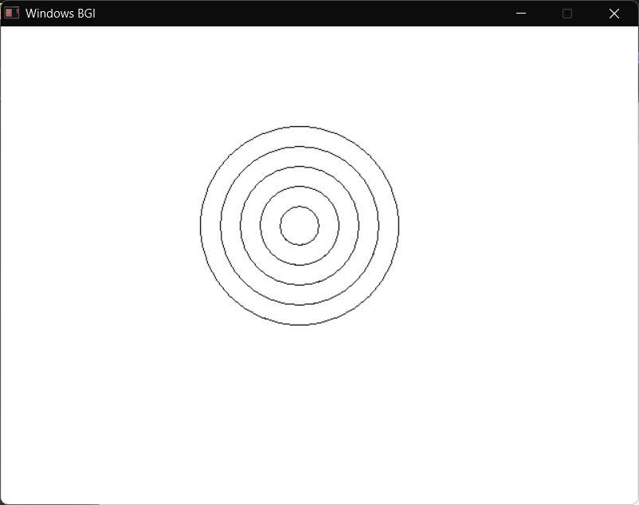
Write a C program to draw a football using graphics functions.
#include <graphics.h>
int main() {
int gd = DETECT, gm;
initgraph(&gd, &gm, (char*)"C:\\Dev-Cpp\\MinGW32\\lib");
// outer circle
circle(300,200,100);
// center pentagon
int p[] = {
300,150,
340,180,
320,230,
280,230,
260,180,
300,150
};
drawpoly(6, p);
// connecting lines
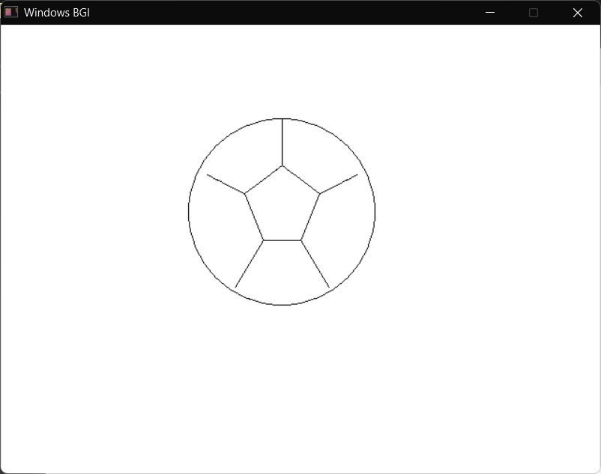
line(300,150, 300,100);
line(340,180, 380,160);
line(320,230, 350,280);
line(280,230, 250,280);
line(260,180, 220,160);

getch();
closegraph();
return 0;
}

Write a C program to draw a rainbow using graphics functions.
#include <graphics.h>
#include <conio.h>

int main() {
int gd = DETECT, gm;
initgraph(&gd, &gm, "");

int colors[] = {RED, YELLOW, GREEN, CYAN, BLUE, MAGENTA, WHITE};

int radius = 120;

for(int i = 0; i < 7; i++) {
setfillstyle(SOLID_FILL, colors[i]);
pieslice(320, 240, 0, 180, radius);
radius -= 15;
}

getch();
closegraph();
return 0;
}
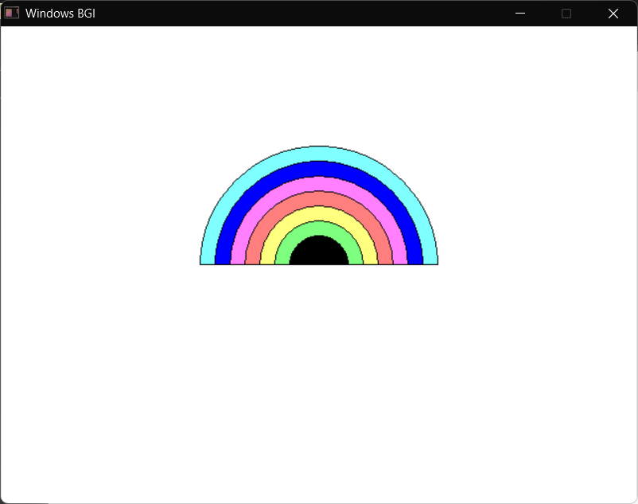
Write a C program to draw a car using graphics functions.
#include <graphics.h>
#include <conio.h>

int main() {
int gd = DETECT, gm;
initgraph(&gd, &gm, (char*)"C:\\Dev-Cpp\\MinGW32\\lib");

rectangle(200, 300, 600, 400);

line(260, 300, 320, 220);
line(320, 220, 520, 220);
line(520, 220, 580, 300);

rectangle(340, 250, 500, 290);

circle(300, 400, 40);
circle(300, 400, 20);

circle(500, 400, 40);
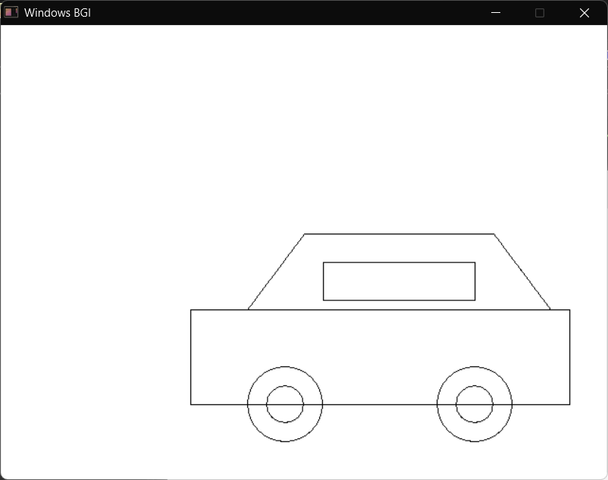
circle(500, 400, 20);

getch();
closegraph();
return 0;
}

Write a C program to draw a house using graphics functions.
#include <graphics.h>
#include <conio.h>
int main() {
int gd = DETECT, gm;
initgraph(&gd, &gm, (char*)"C:\\Dev-Cpp\\MinGW32\\lib");

// base rectangle
rectangle(200,250,600,450);
line(400,250,400,450);

line(200,250,300,150);
line(300,150,400,250);

line(300,150,600,150);
line(600,150,600,250);

circle(300,220,20);

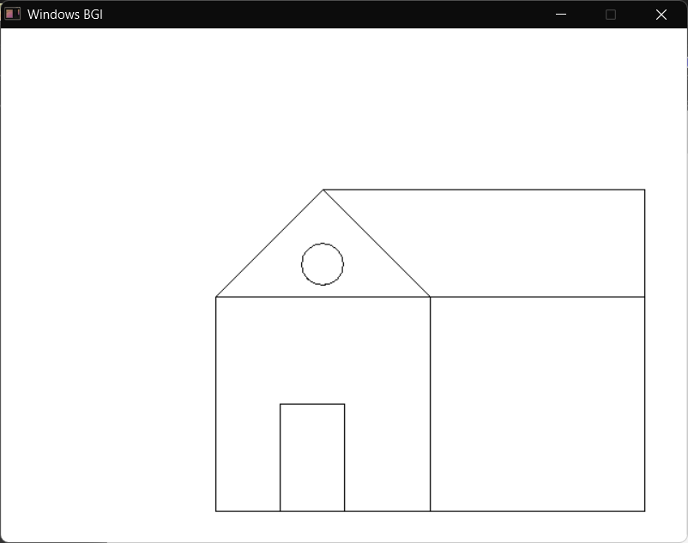
rectangle(260,350,320,450);

getch();
closegraph();
return 0;
}

Write a C program to draw a rectangle with its diagonals using graphics functions.
#include <graphics.h>
#include <conio.h>

int main() {
int gd = DETECT, gm;
initgraph(&gd, &gm, (char*)"C:\\Dev-Cpp\\MinGW32\\lib");

// rectangle
rectangle(200,200,500,350);

// diagonals
line(200,200,500,350);
line(200,350,500,200);

getch();
closegraph();
return 0;
}
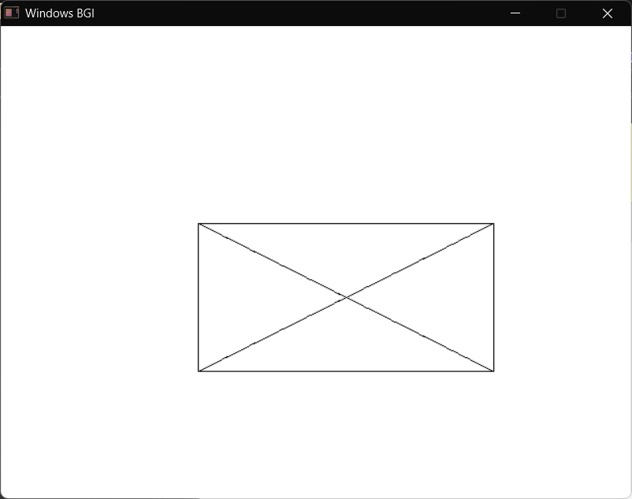
Write a C program to draw a rectangle with diagonals and semicircles on all four sides using graphics functions.
#include <graphics.h>
#include <conio.h>

int main() {
int gd = DETECT, gm;
initgraph(&gd, &gm, (char*)"C:\\Dev-Cpp\\MinGW32\\lib");
rectangle(250,200,450,350);
line(250,200,450,350);
line(250,350,450,200);

// top semicircle
arc(350,200,0,180,100);

// bottom semicircle
arc(350,350,180,360,100);

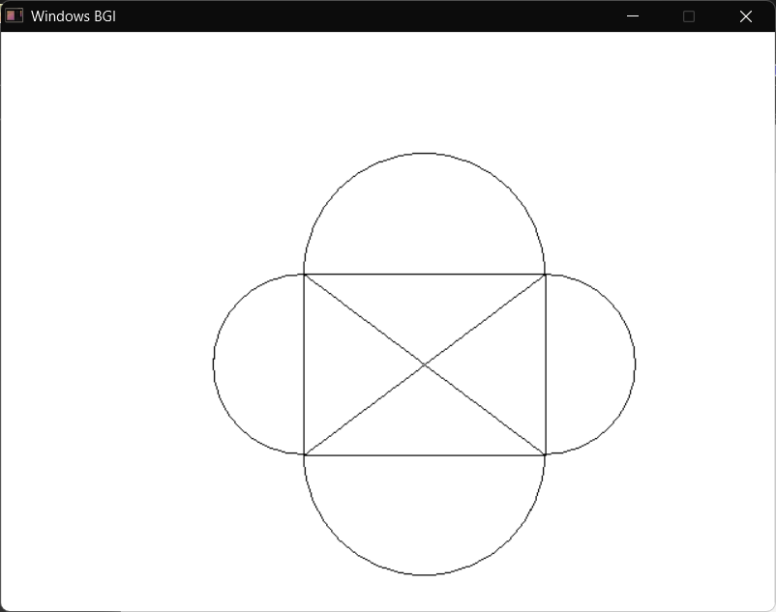
// left semicircle
arc(250,275,90,270,75);

// right semicircle
arc(450,275,270,90,75);

getch();
closegraph();
return 0;
}

Write a C program to draw a rectangle with diagonals and triangles on all four sides using graphics functions.
#include <graphics.h>
#include <conio.h>

int main() {
int gd = DETECT, gm;
initgraph(&gd, &gm, (char*)"C:\\Dev-Cpp\\MinGW32\\lib");

// center rectangle
rectangle(300,250,500,350);

// diagonals inside rectangle
line(300,250,500,350);
line(300,350,500,250);

// top triangle
line(300,250,400,150);
line(400,150,500,250);

// bottom triangle
line(300,350,400,450);
line(400,450,500,350);

// left triangle
line(300,250,200,300);
line(200,300,300,350);

// right triangle
line(500,250,600,300);
line(600,300,500,350);

getch();
closegraph();
return 0;
}

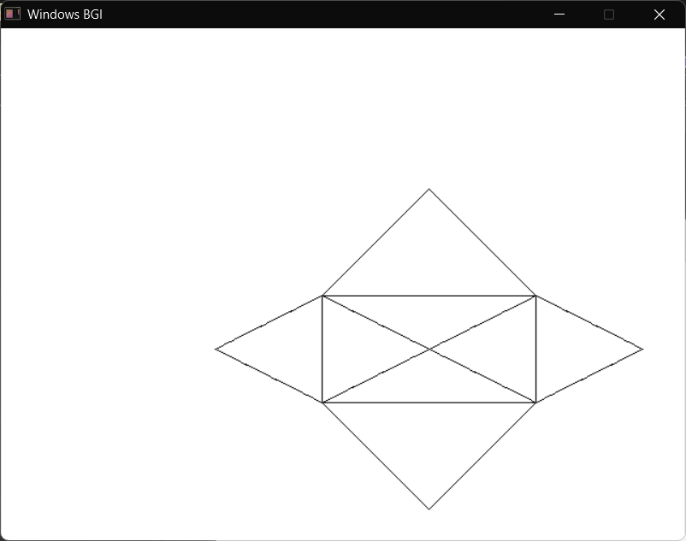

Draw an 8-sided star (spike shape) using graphics.h.
#include <graphics.h>
#include <conio.h>
#include <math.h>

int main() {
int gd = DETECT, gm;
initgraph(&gd, &gm, "");

int cx = 250, cy = 250; // center
int r1 = 80; // inner radius
int r2 = 150; // outer spike radius

for (int i = 0; i < 8; i++) {
float angle = i * 45 * M_PI / 180.0;
float next = (i + 1) * 45 * M_PI / 180.0;
float mid = angle + (22.5 * M_PI / 180.0);

// Inner points
int x1 = cx + r1 * cos(angle);
int y1 = cy - r1 * sin(angle);

int x2 = cx + r1 * cos(next);
int y2 = cy - r1 * sin(next);

// Outer spike
int xo = cx + r2 * cos(mid);
int yo = cy - r2 * sin(mid);

// Draw petal shape
line(x1, y1, xo, yo);
line(xo, yo, x2, y2);

// Draw spoke
line(cx, cy, x1, y1);
}

// Close center spokes
line(cx, cy, cx + r1, cy);

getch();
closegraph();
return 0;
}
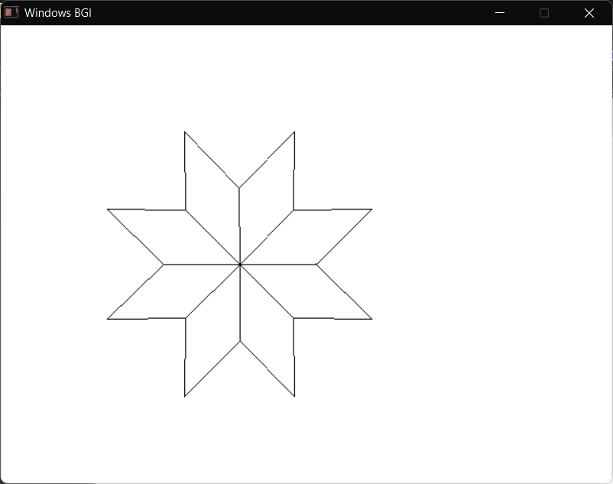

Write a C program to draw a Sierpiński-style triangle using graphics functions.
#include <graphics.h>
#include <conio.h>

int main() {
int gd = DETECT;
int gm;
initgraph(&gd, &gm, (char*)"C:\\Dev-Cpp\\MinGW32\\lib");

// -------- MAIN TRIANGLE POINTS --------
int x1 = 320;
int y1 = 50;

int x2 = 120;
int y2 = 400;

int x3 = 520;
int y3 = 400;

// -------- MIDPOINTS (LEVEL 1) --------
int m12x = (x1 + x2) / 2;
int m12y = (y1 + y2) / 2;

int m13x = (x1 + x3) / 2;
int m13y = (y1 + y3) / 2;

int m23x = (x2 + x3) / 2;
int m23y = (y2 + y3) / 2;

// -------- LEVEL 2 MIDPOINTS --------
// Top
int t1x = (x1 + m12x) / 2;
int t1y = (y1 + m12y) / 2;

int t2x = (x1 + m13x) / 2;
int t2y = (y1 + m13y) / 2;

int t3x = (m12x + m13x) / 2;
int t3y = (m12y + m13y) / 2;

// Left
int l1x = (x2 + m12x) / 2;
int l1y = (y2 + m12y) / 2;

int l2x = (x2 + m23x) / 2;
int l2y = (y2 + m23y) / 2;

int l3x = (m12x + m23x) / 2;
int l3y = (m12y + m23y) / 2;

// Right
int r1x = (x3 + m13x) / 2;
int r1y = (y3 + m13y) / 2;

int r2x = (x3 + m23x) / 2;
int r2y = (y3 + m23y) / 2;

int r3x = (m13x + m23x) / 2;
int r3y = (m13y + m23y) / 2;

// -------- OUTER TRIANGLE --------
int outer[] = {
x1, y1,
x2, y2,
x3, y3,
x1, y1
};
drawpoly(4, outer);

// -------- CENTER TRIANGLE --------
int center[] = {
m12x, m12y,
m13x, m13y,
m23x, m23y,
m12x, m12y
};
drawpoly(4, center);

// -------- TOP SMALL --------
int top[] = {
t1x, t1y,
t2x, t2y,
t3x, t3y,
t1x, t1y
};
drawpoly(4, top);

// -------- LEFT SMALL --------
int left[] = {
l1x, l1y,
l2x, l2y,
l3x, l3y,
l1x, l1y
};
drawpoly(4, left);

// -------- RIGHT SMALL --------
int right[] = {
r1x, r1y,
r2x, r2y,
r3x, r3y,
r1x, r1y
};
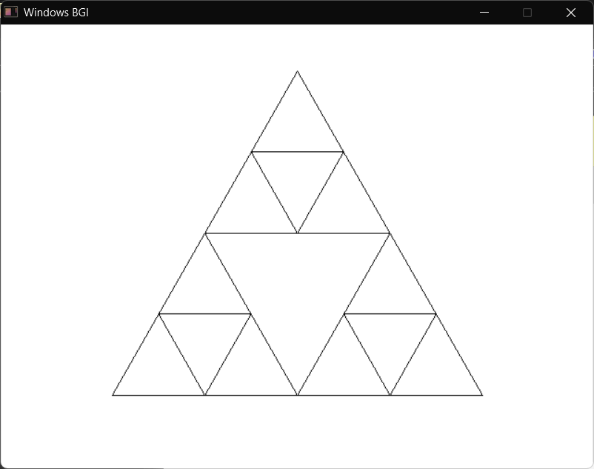
drawpoly(4, right);

getch();
closegraph();
return 0;
}

Write a C program to draw a moving car with a continuously moving road line using graphics functions.
#include <graphics.h>
#include <conio.h>
#include <dos.h>

int main() {
int gd = DETECT, gm;
initgraph(&gd, &gm, (char*)"C:\\Dev-Cpp\\MinGW32\\lib");

int x = 0;
int lineOffset = 0;

while(!kbhit()) {
cleardevice();

rectangle(200 + x, 300, 600 + x, 400);

line(260 + x, 300, 320 + x, 220);
line(320 + x, 220, 520 + x, 220);
line(520 + x, 220, 580 + x, 300);

rectangle(340 + x, 250, 500 + x, 290);

circle(300 + x, 400, 40);
circle(300 + x, 400, 20);

circle(500 + x, 400, 40);
circle(500 + x, 400, 20);

for(int i = 0; i < 640; i += 40) {
line(i + lineOffset, 450, i + 20 + lineOffset, 450);
}

delay(30);

x += 5;
lineOffset -= 5;

if(x > 200) x = 0;
if(lineOffset < -40) lineOffset = 0;
}

getch();
closegraph();
return 0;
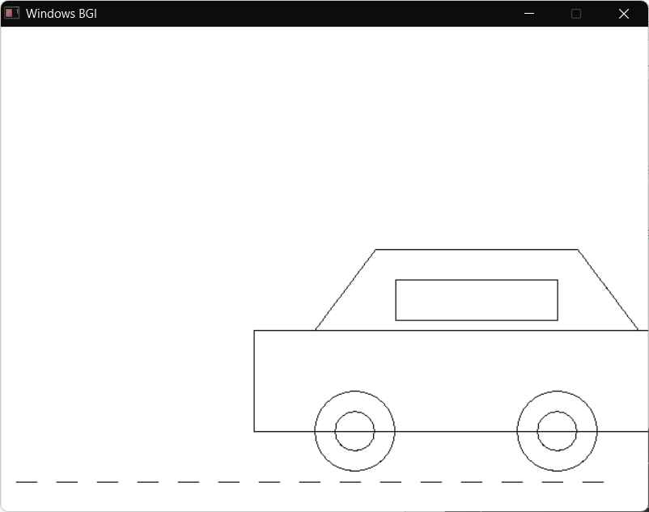
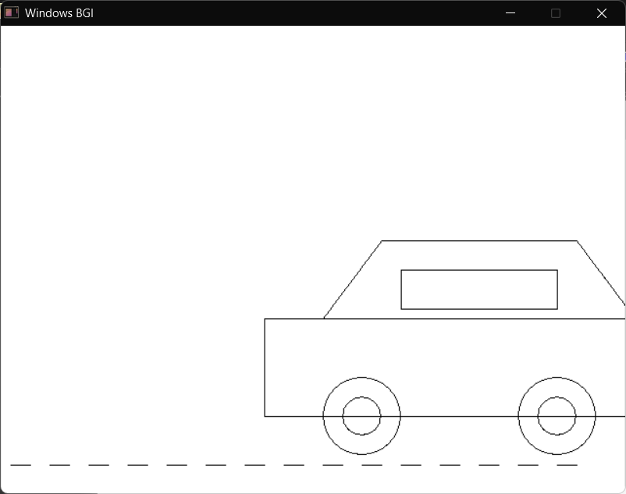
}

Write a C program to draw a simple Diya (Deepa lamp) using graphics functions.
#include <graphics.h>
#include <conio.h>

int main() {
int gd = DETECT, gm;
initgraph(&gd, &gm, (char*)"C:\\Dev-Cpp\\MinGW32\\lib");

setcolor(WHITE);
setlinestyle(SOLID_LINE, 0, THICK_WIDTH);

arc(300, 200, 180, 360, 100);

ellipse(300, 200, 0, 360, 100, 25);

ellipse(240, 140, 90, 270, 30, 60);
ellipse(215, 140, 270, 450, 30, 60);

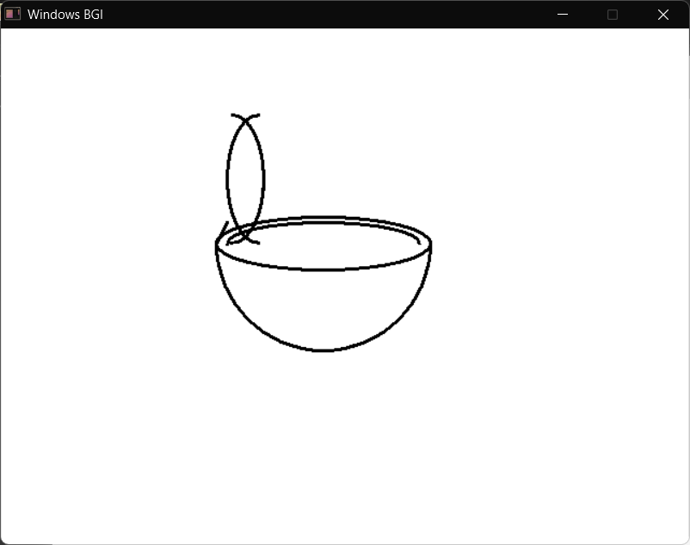
line(200, 200, 210, 180);

ellipse(300, 200, 0, 180, 90, 20);

getch();
closegraph();
return 0;
}

Write a C program to draw a traffic light with colors using graphics functions.
#include <graphics.h>
#include <conio.h>

int main() {
int gd = DETECT;
int gm;
initgraph(&gd, &gm, (char*)"C:\\Dev-Cpp\\MinGW32\\lib");

rectangle(280, 100, 360, 300);
circle(320, 140, 25);
circle(320, 200, 25);
circle(320, 260, 25);

setfillstyle(SOLID_FILL, RED);
floodfill(320, 140, WHITE);

setfillstyle(SOLID_FILL, YELLOW);
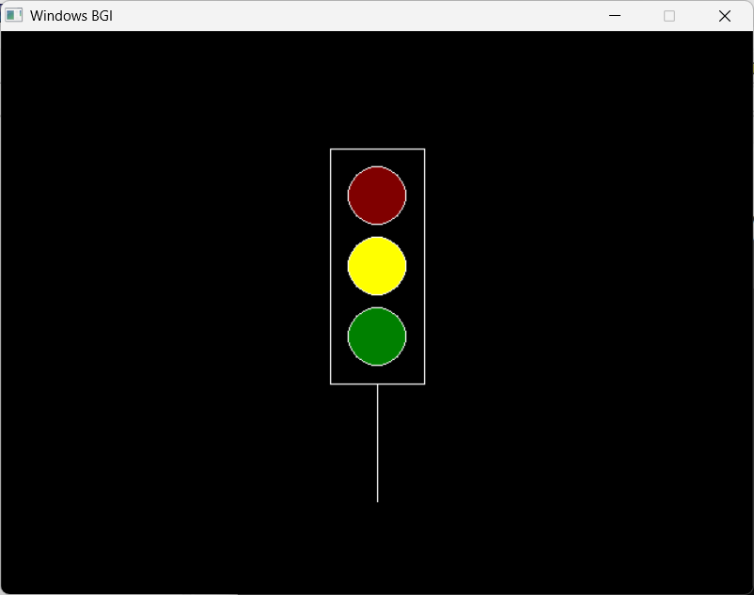
floodfill(320, 200, WHITE);

setfillstyle(SOLID_FILL, GREEN);
floodfill(320, 260, WHITE);
line(320, 300, 320, 400);

getch();
closegraph();
return 0;
}
Write a C program to draw a butterfly using graphics functions.
#include <graphics.h>
#include <conio.h>

int main() {
int gd = DETECT, gm;
initgraph(&gd, &gm, (char*)"C:\\Dev-Cpp\\MinGW32\\lib");
setlinestyle(SOLID_LINE, 0, THICK_WIDTH);
// 1. Head and Body
circle(300, 160, 12);
ellipse(300, 210, 0, 360, 8, 40);

// 2. Right Wings (Top & Bottom)
ellipse(340, 185, 0, 360, 40, 30);
ellipse(335, 225, 0, 360, 30, 20);
// 3. Left Wings (Top & Bottom)
ellipse(260, 185, 0, 360, 40, 30);
ellipse(265, 225, 0, 360, 30, 20);
// 4. Small Circles on Upper Wings
circle(355, 185, 8);
circle(245, 185, 8);
// 5. Simple Antennae
line(295, 150, 280, 130);
line(305, 150, 320, 130);

getch();
closegraph();
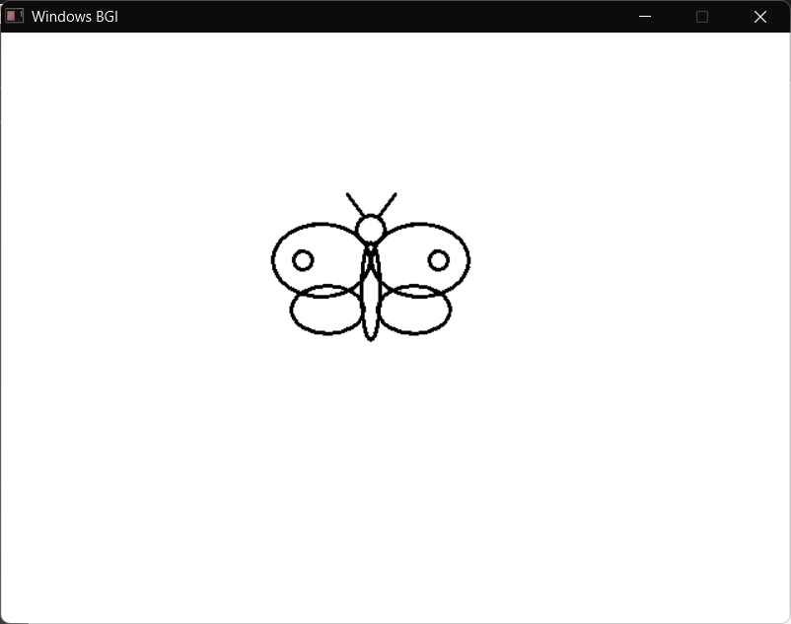
return 0;
}
Write a C program to display numbers from 1 to 10 on the screen using graphics functions.
#include <graphics.h>
#include <conio.h>
#include <stdio.h>

int main() {
int gd = DETECT;
int gm;
initgraph(&gd, &gm, (char*)"C:\\Dev-Cpp\\MinGW32\\lib");

char str[5];
int y = 50;

for(int i = 1; i <= 10; i++) {
sprintf(str, "%d", i);
outtextxy(300, y, str);
y += 30;
}

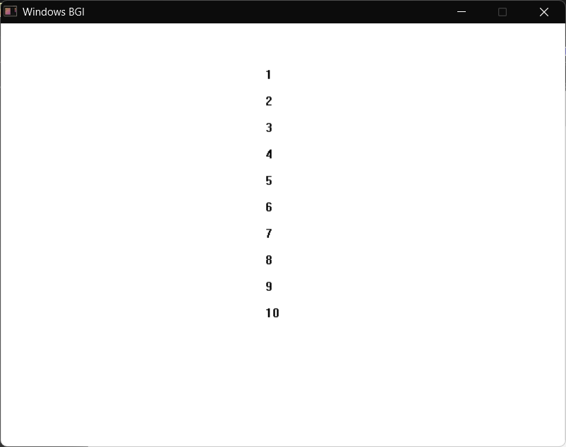
getch();
closegraph();
return 0;
}

Write a C program to perform translation of a triangle.
#include <graphics.h>
#include <conio.h>
#include <dos.h>

int main() {
int gd = DETECT, gm;
initgraph(&gd, &gm, (char*)"C:\\Dev-Cpp\\MinGW32\\lib");

int x1=200,y1=200, x2=250,y2=100, x3=300,y3=200;

line(x1,y1,x2,y2);
line(x2,y2,x3,y3);
line(x3,y3,x1,y1);

delay(2000);

int tx=100, ty=50;

line(x1+tx,y1+ty, x2+tx,y2+ty);
line(x2+tx,y2+ty, x3+tx,y3+ty);
line(x3+tx,y3+ty, x1+tx,y1+ty);
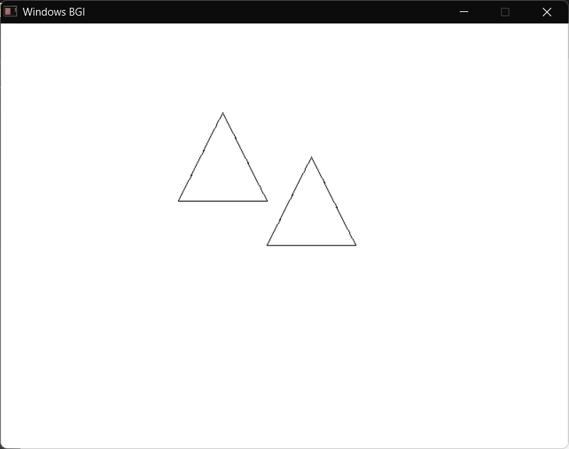
getch();
closegraph();
}

Write a C program to perform scaling of a triangle.
#include <graphics.h>
#include <conio.h>
#include <dos.h>

int main() {
int gd = DETECT, gm;
initgraph(&gd, &gm, (char*)"C:\\Dev-Cpp\\MinGW32\\lib");

int x1=200,y1=200, x2=250,y2=100, x3=300,y3=200;

line(x1,y1,x2,y2);
line(x2,y2,x3,y3);
line(x3,y3,x1,y1);

delay(2000);

float sx=1.5, sy=1.5;

line(x1*sx,y1*sy, x2*sx,y2*sy);
line(x2*sx,y2*sy, x3*sx,y3*sy);
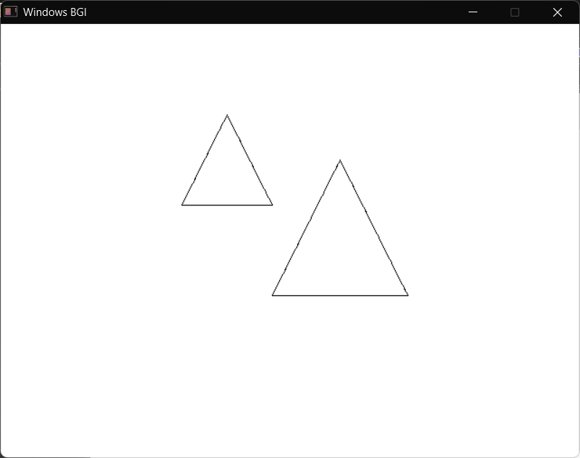
line(x3*sx,y3*sy, x1*sx,y1*sy);

getch();
closegraph();
}

Write a C program to perform rotation of a triangle.
#include <graphics.h>
#include <conio.h>
#include <dos.h>
#include <math.h>

#define PI 3.1416

int main() {
int gd = DETECT, gm;
initgraph(&gd, &gm, (char*)"C:\\Dev-Cpp\\MinGW32\\lib");

int x1=200,y1=200, x2=250,y2=100, x3=300,y3=200;

line(x1,y1,x2,y2);
line(x2,y2,x3,y3);
line(x3,y3,x1,y1);

delay(2000);

float angle = 45 * PI/180;

int x1r = x1*cos(angle) - y1*sin(angle);
int y1r = x1*sin(angle) + y1*cos(angle);

int x2r = x2*cos(angle) - y2*sin(angle);
int y2r = x2*sin(angle) + y2*cos(angle);

int x3r = x3*cos(angle) - y3*sin(angle);
int y3r = x3*sin(angle) + y3*cos(angle);

line(x1r,y1r,x2r,y2r);
line(x2r,y2r,x3r,y3r);
line(x3r,y3r,x1r,y1r);

getch();
closegraph();
}

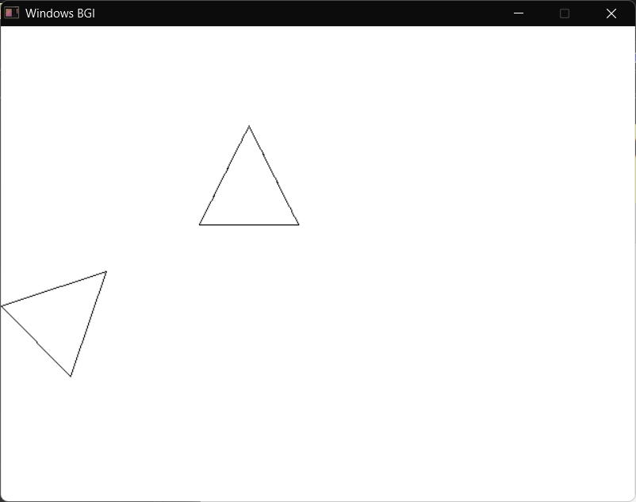

Write a C program to perform reflection of a triangle about X-axis.
#include <graphics.h>
#include <conio.h>
#include <dos.h>

int main() {
int gd = DETECT, gm;
initgraph(&gd, &gm, (char*)"C:\\Dev-Cpp\\MinGW32\\lib");

int x1=200,y1=200, x2=250,y2=100, x3=300,y3=200;

line(x1,y1,x2,y2);
line(x2,y2,x3,y3);
line(x3,y3,x1,y1);

delay(2000);

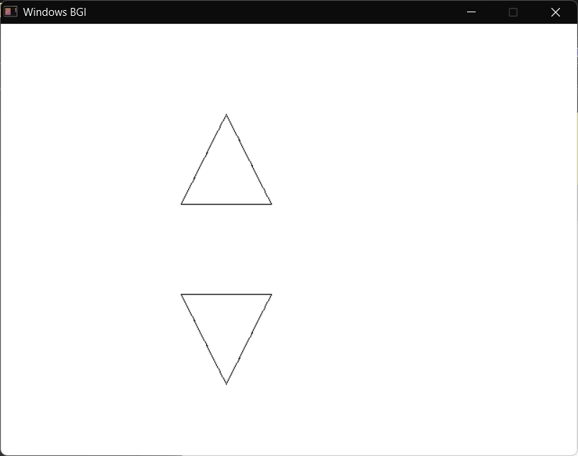
int mid = 250;

line(x1,2*mid-y1, x2,2*mid-y2);
line(x2,2*mid-y2, x3,2*mid-y3);
line(x3,2*mid-y3, x1,2*mid-y1);

getch();
closegraph();
}

Write a C program to perform shearing of a triangle.
#include <graphics.h>
#include <conio.h>
#include <dos.h>

int main() {
int gd = DETECT, gm;
initgraph(&gd, &gm, (char*)"C:\\Dev-Cpp\\MinGW32\\lib");

int x1=200,y1=200, x2=250,y2=100, x3=300,y3=200;

line(x1,y1,x2,y2);
line(x2,y2,x3,y3);
line(x3,y3,x1,y1);

delay(2000);
float shx = 1.5;

int x1s = x1 + shx*y1;
int x2s = x2 + shx*y2;
int x3s = x3 + shx*y3;

line(x1s,y1,x2s,y2);
line(x2s,y2,x3s,y3);
line(x3s,y3,x1s,y1);

getch();
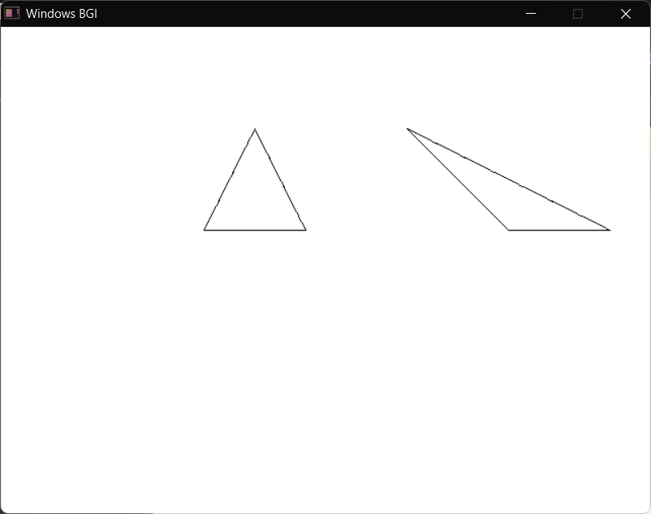
closegraph();
}
Write a C program to perform 3D translation of a triangle.
#include <graphics.h>
#include <conio.h>
#include <dos.h>
int main() {
int gd=DETECT, gm;
initgraph(&gd,&gm,(char*)"C:\\Dev-Cpp\\MinGW32\\lib");
int x[3]={200,250,300};
int y[3]={200,100,200};
int z[3]={0,0,0};

for(int i=0;i<3;i++)
line(x[i],y[i],x[(i+1)%3],y[(i+1)%3]);

delay(2000);
int xp[3], yp[3];
int tx=50, ty=50, tz=50;

for(int i=0;i<3;i++){
x[i]+=tx; y[i]+=ty; z[i]+=tz;
xp[i]=x[i]+z[i]*0.5;
yp[i]=y[i]-z[i]*0.5;
}

for(int i=0;i<3;i++)
line(xp[i],yp[i],xp[(i+1)%3],yp[(i+1)%3]);
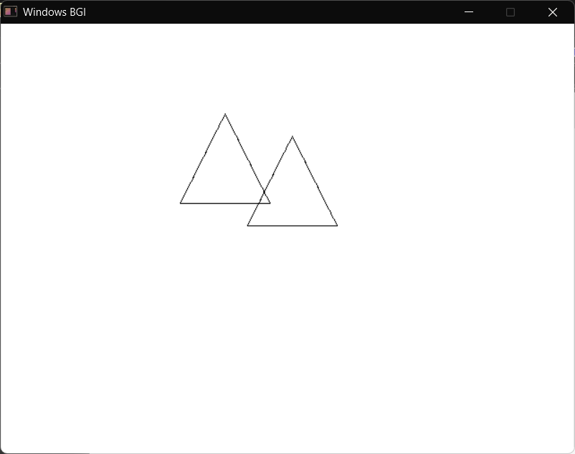
getch();
}

Write a C program to perform 3D scaling of a triangle.
#include <graphics.h>
#include <conio.h>
#include <dos.h>

int main(){
int gd=DETECT, gm;
initgraph(&gd,&gm,(char*)"C:\\Dev-Cpp\\MinGW32\\lib");

int x[3]={200,250,300};
int y[3]={200,100,200};
int z[3]={0,0,0};

for(int i=0;i<3;i++)
line(x[i],y[i],x[(i+1)%3],y[(i+1)%3]);
delay(2000);

int xp[3], yp[3];
float sx=1.5, sy=1.5, sz=1.5;

for(int i=0;i<3;i++){
x[i]*=sx; y[i]*=sy; z[i]*=sz;
xp[i]=x[i]+z[i]*0.5;
yp[i]=y[i]-z[i]*0.5;
}
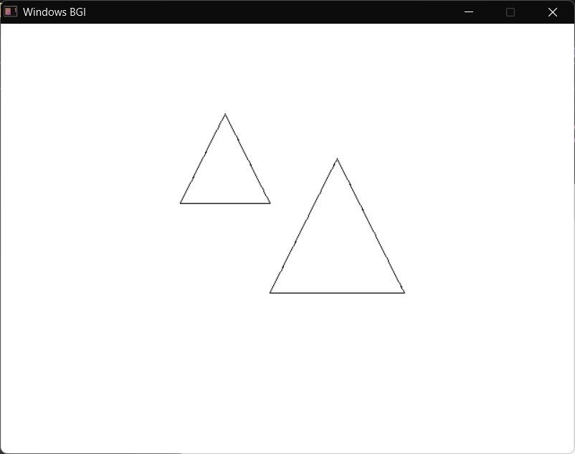
for(int i=0;i<3;i++)
line(xp[i],yp[i],xp[(i+1)%3],yp[(i+1)%3]);
getch();
}
Write a C program to perform 3D rotation of a triangle.
#include <graphics.h>
#include <conio.h>
#include <dos.h>
#include <math.h>

#define PI 3.1416

int main(){
int gd=DETECT, gm;
initgraph(&gd,&gm,(char*)"C:\\Dev-Cpp\\MinGW32\\lib");

int x[3]={200,250,300};
int y[3]={200,100,200};
int z[3]={0,0,0};

for(int i=0;i<3;i++)
line(x[i],y[i],x[(i+1)%3],y[(i+1)%3]);

delay(2000);

int xp[3], yp[3];
float angle=45*PI/180;

for(int i=0;i<3;i++){
int xr = x[i]*cos(angle) - y[i]*sin(angle);
int yr = x[i]*sin(angle) + y[i]*cos(angle);
x[i]=xr; y[i]=yr;

xp[i]=x[i]+z[i]*0.5;
yp[i]=y[i]-z[i]*0.5;
}

for(int i=0;i<3;i++)
line(xp[i],yp[i],xp[(i+1)%3],yp[(i+1)%3]);

getch();
}

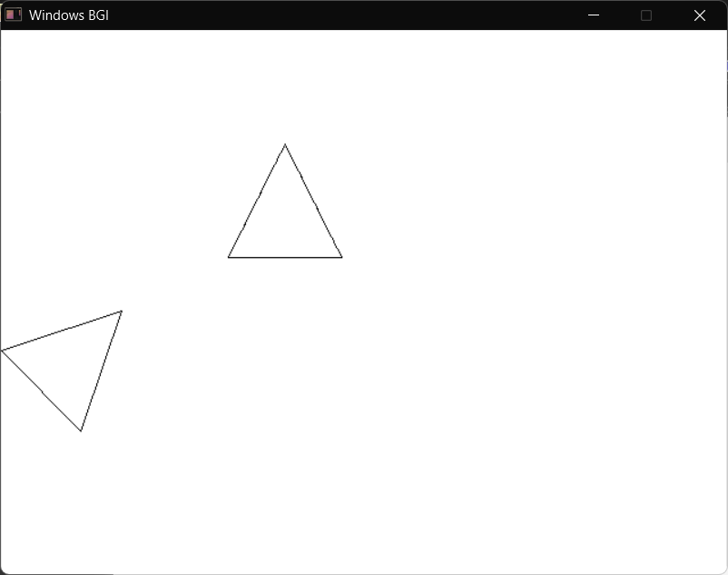

Write a C program to perform 3D reflection of a triangle.
#include <graphics.h>
#include <conio.h>
#include <dos.h>

int main(){
int gd=DETECT, gm;
initgraph(&gd,&gm,(char*)"C:\\Dev-Cpp\\MinGW32\\lib");

int x[3]={200,250,300};
int y[3]={200,100,200};
int z[3]={0,0,0};

// ORIGINAL TRIANGLE (WHITE)
setcolor(WHITE);
for(int i=0;i<3;i++)
line(x[i],y[i],x[(i+1)%3],y[(i+1)%3]);

delay(2000);

int xp[3], yp[3];

// REFLECTED TRIANGLE (YELLOW)
setcolor(YELLOW);
for(int i=0;i<3;i++){
int yr = 400 - y[i];

xp[i] = x[i] + z[i]*0.5;
yp[i] = yr - z[i]*0.5;
}

for(int i=0;i<3;i++)
line(xp[i],yp[i],xp[(i+1)%3],yp[(i+1)%3]);

getch();
closegraph();
}

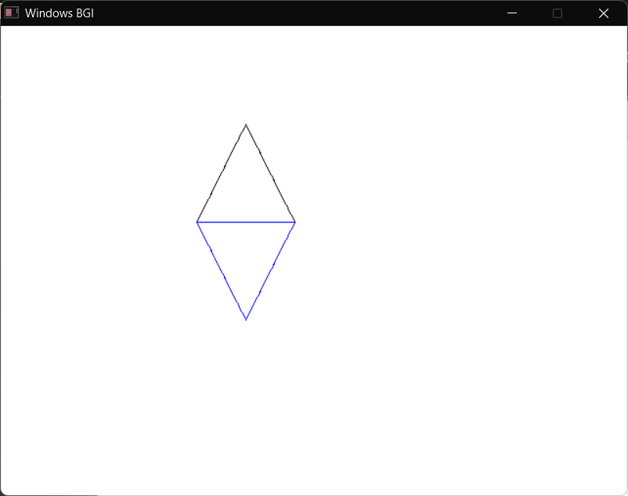

Write a C program to perform 3D shearing of a triangle.
#include <graphics.h>
#include <conio.h>
#include <dos.h>
int main(){
int gd=DETECT, gm;
initgraph(&gd,&gm,(char*)"C:\\Dev-Cpp\\MinGW32\\lib");
int x[3]={200,250,300};
int y[3]={200,100,200};
int z[3]={0,0,0};

for(int i=0;i<3;i++)
line(x[i],y[i],x[(i+1)%3],y[(i+1)%3]);
delay(2000);

int xp[3], yp[3];
float sh=1.0;

for(int i=0;i<3;i++){
x[i]=x[i]+sh*y[i];

xp[i]=x[i]+z[i]*0.5;
yp[i]=y[i]-z[i]*0.5;
}

for(int i=0;i<3;i++)
line(xp[i],yp[i],xp[(i+1)%3],yp[(i+1)%3]);
getch();
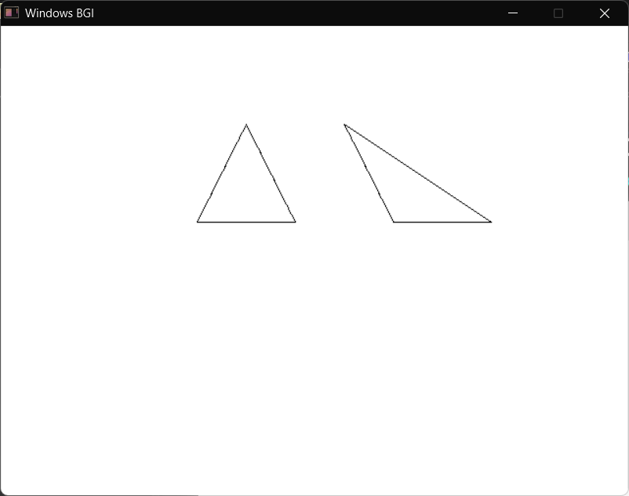
}
Write a C program to implement the DDA (Digital Differential Analyzer) line drawing algorithm using graphics functions.
//DDA Line Drawing Algorithm
#include <graphics.h>
#include <stdio.h>
#include <math.h>

int main()
{
int gd = DETECT, gm;
int x1, y1, x2, y2;
float dx, dy, steps, xinc, yinc, x, y;

initgraph(&gd, &gm, (char*)"C:\\Dev-Cpp\\MinGW32\\lib");

printf("Enter starting point (x1, y1): ");
scanf("%d %d", &x1, &y1);

printf("Enter ending point (x2, y2): ");
scanf("%d %d", &x2, &y2);

dx = x2 - x1;
dy = y2 - y1;

if (abs(dx) > abs(dy))
steps = abs(dx);
else
steps = abs(dy);

xinc = dx / steps;
yinc = dy / steps;

x = x1;
y = y1;

for (int i = 0; i <= steps; i++)
{
delay(500);
putpixel(round(x), round(y), WHITE);
x = x + xinc;
y = y + yinc;
}

getch();
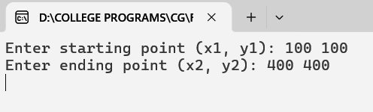
closegraph();

return 0;
}
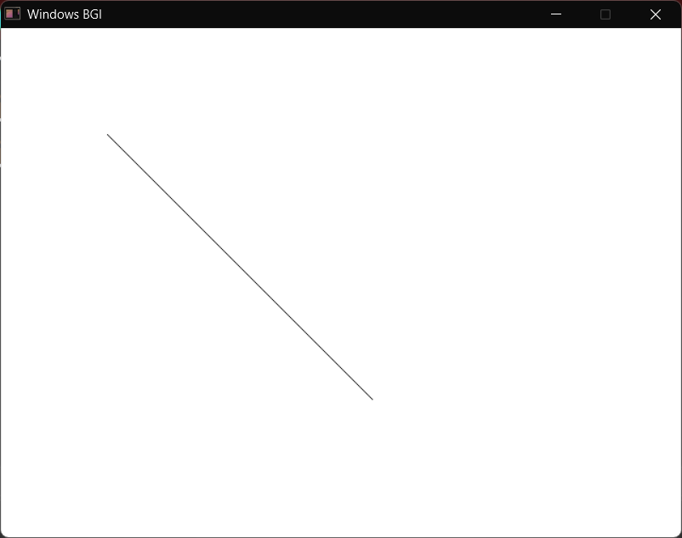

Write a C program to implement Bresenham’s line drawing algorithm using graphics functions.
//Bresenham
#include <graphics.h>
#include <stdio.h>
#include <stdlib.h>
int main()
{
int gd = DETECT, gm;
int x1, y1, x2, y2;
int dx, dy, p, x, y;
initgraph(&gd, &gm, (char*)"C:\\Dev-Cpp\\MinGW32\\lib");
printf("Enter x1 y1 :");
scanf("%d %d", &x1, &y1);
printf("Enter x2 y2 :");
scanf("%d %d", &x2, &y2);

if (x1 > x2)
{
int temp = x1;
x1 = x2;
x2 = temp;
temp = y1;
y1 = y2;
y2 = temp;
}

x = x1;
y = y1;

dx = abs(x2 - x1);
dy = abs(y2 - y1);

p = 2 * dy - dx;

while (x <= x2)
{
delay(100);
putpixel(x, y, WHITE);

if (p < 0)
{
p = p + 2 * dy;
}
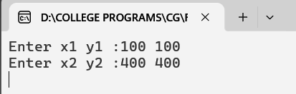
else
{
y = y + 1;
p = p + 2 * dy - 2 * dx;
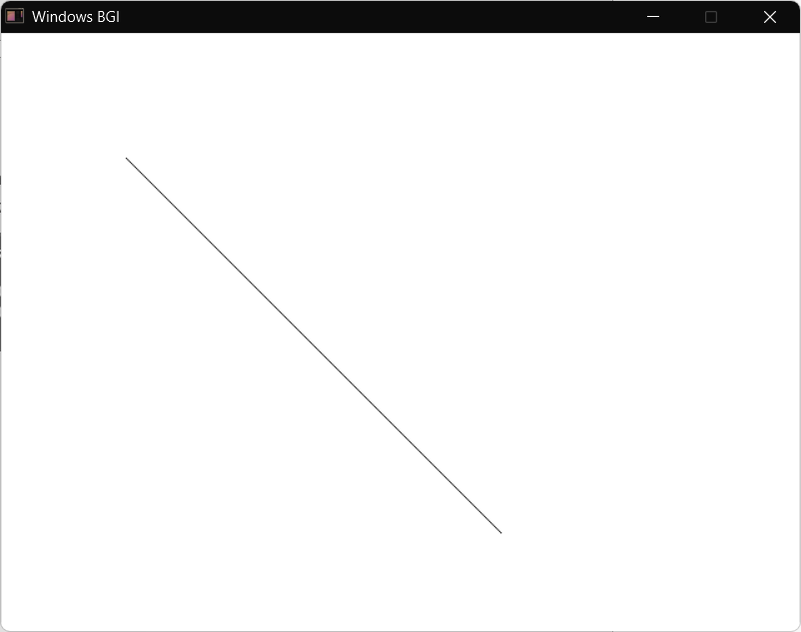
}

x = x + 1;
}

getch();
closegraph();

return 0;
}
Write a C program to implement the Midpoint Circle Drawing Algorithm using graphics functions.
#include <graphics.h>
#include <conio.h>
#include <stdio.h>
#include <dos.h>

void plotpoints(int xc, int yc, int x, int y) {
putpixel(xc + x, yc + y, WHITE);
putpixel(xc - x, yc + y, WHITE);
putpixel(xc + x, yc - y, WHITE);
putpixel(xc - x, yc - y, WHITE);
putpixel(xc + y, yc + x, WHITE);
putpixel(xc - y, yc + x, WHITE);
putpixel(xc + y, yc - x, WHITE);
putpixel(xc - y, yc - x, WHITE);
}

int main() {
int gd = DETECT, gm;
initgraph(&gd, &gm, (char*)"C:\\Dev-Cpp\\MinGW32\\lib");

int xc, yc, r;

printf("Enter center (xc yc): ");
scanf("%d %d", &xc, &yc);

printf("Enter radius: ");
scanf("%d", &r);

int x = 0;
int y = r;
int p = 1 - r;

while(x <= y) {
delay(20);
plotpoints(xc, yc, x, y);

x++;

if(p < 0) {
p = p + 2*x + 1;
} else {
y--;
p = p + 2*x + 1 - 2*y;
}
}
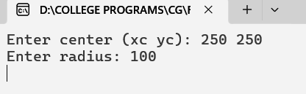
getch();
closegraph();
return 0;



